**RATING RELIABILITY OF ONLINE PRODUCT REVIEWS**

**Aman Khan (amank2061@gmail.com)**

**Abstract:**

In the modern times of online shopping, its easy to get catfished. Usually buyers tend to crave for warranty, in this case the closest thing to warranty is coverage done by other customers.

Suppose you are trying to purchase a product which has only 3 reviews and all of them are positive, but when you receive the product its quality is not as advertised, reviewed or not up to your expectations.

Chances are those reviews were added to lure customers, since it’s easy to deceive people with enchanting things.

This model tries to break down into the Reviews part of an online shopping site (Amazon).And suggests us reviews based on a reliability rate.

**Design:**

This model is split to:

1. Study the relationship between online reviews and how customers approach to them.
2. Deciding parameters from a human’s perspective.
3. Categorising the statements based on various parameters
4. Attaching values to each statement like a score.
5. Categorizing the statements based on the reliability rate.

**Parameters**:

To understand what goes on in a person’s mind when he is captivated by the reviews we must try to look at all the items at display.

These attributes help gain his trust.

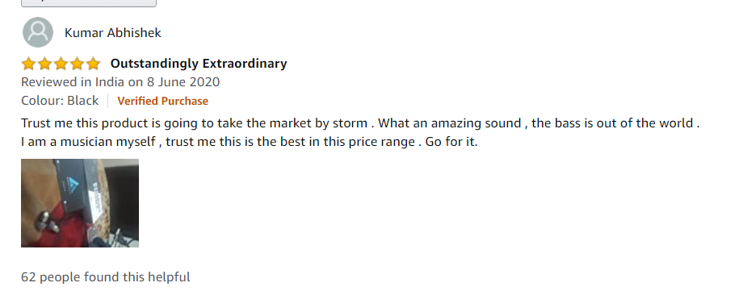

Considering parameters and attributes in a project where I need to understand thinking of the masses I decided to take a poll.

I took inputs from a google doc form which I have shared, before deciding these attributes. (Below)

From a raw perspective we get stars count, verified tag, people who found it helpful count, images and date.

Also we could access edited tag.

Verified purchase: According to their website-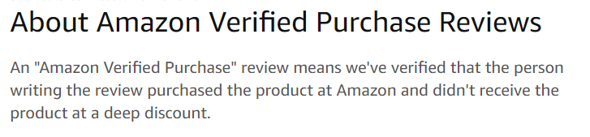

In our dataset verified attribute is valued as 1 for verified and 0 for not.

Edited Review:

Suppose customer who has purchased a product would like to change his opinion, edited tags make his reviews more reliable.

In our dataset edited attribute is also valued as 1 for edited and 0 for not.

Images:

Reviews with images are most reliable of course.

It could give them a boost in the score already.

But images are not considered in my project and the reason I have pushed into the recession section.

Date:

Consider product released an year ago.

Initially it was gaining positive response.

But in recent days, either because there are better products in market or people are not satisfied, they put critical reviews.

This situation can work both ways, initially they got critical reviews but over time people started liking it later.

Or, only positive/negative reviews ever since it released.

Basically people fall into the misconception that recent reviews are more reliable. But its not true.

Hence, I will not consider dates for this model.

Count of people who found this helpful:

Top reviews get the highest count. Naturally potential customers trust these reviews with more helpful count.

**Working:**

Based on the above parameters I figured these are the general filters and tried to gather whatever resources available on the internet. Related to it.

I programmed the first part to sort the reviews based on feelings .

It will rate the review out of 4. If the review is too positive or too negative it will get a score of 4. If it is neutral it will get score around 0 or 1.

In the next phase the program would apply filters to the remaining parameters.

Which is to check verified, edited and the helpful count.

From the dataset verified and edited have 0,1 values.

Those reviews with 1 values in verified section are more reliable. And hence they will get increments in their points.

Whereas for edited section 0 values will get increments.

We take the highest helpful count in a variable and use it to compare with other counts. We get a ratio based on which the score is incremented.

From all the collected score we give ratings in suitable percentages to each review.

**Reasons for my recessions:**

As mentioned before, I did not consider Images because we cannot risk reading false images.

Meaning, consider the product looking for is an specific model of an earphone, but images uploaded are of a different earphones. For Human eyes it distinguishable, but for my model it would require me to build image classification project.

I used dummy datasets, since I could not create a website scraper or a crawler that would help read all the attributes. Also after web searching, appropriate datasets were not available in the required format.

**Take away:**

Each customer is different, he/she has a different expectations from the product and therefore a different opinions. But one thing common is that these opinions can be changed as they get biased after reading the reviews.

Another take-away from my analysis is that users must be shielded from unreliable reviews since it would waste their time, efforts and decrease their trust on the seller or the website.

**Future Scope:**

This model was built on assumptions made on front end part of Amazon. The display part. Naturally if this was used by Amazon itself they could use it to sort the ratings again.

Also it could be used by, for and on other E-commerce platforms and companies after they tweak the working to suit themselves.

This model should not be limited to reviews itself. Consider a broader perspective With considerable tweaks it could be used on Platforms like Twitter, Youtube and Facebook.